# Calculator Functions

| **Normal distribution functions** | **Syntax and purpose** |
| --- | --- |
| Normalpdf | Normalpdf(x, mean, standard deviation)   * To graph a normal curve |
| Normalcdf | Normalcdf( lower bound, upper bound, mean, standard deviation)   * Gives you the area below a certain point or between 2 points |
| invNorm | invNorm(probability, mean, standard deviation)   * It will give you the x value that the probability was derived from * Ex) if you want to know what x value gives you the 90th percentile, you do **invNorm(.9, mean, sd)** and it gives you the x value |
| invT | invT(probability, degrees of freedom)   * This will give you your t value |
| Binompdf | Binompdf(n, probability, x)   * Gives you the probability of something happening at a certain x value * Only one point, not a range |
| Binomcdf | Binomcdf(n, probability x)   * Gives you the probability of $≤$ x happening |
| Geometpdf | Geometpdf(proabaility, x)   * Gives you the probability of x happening if n is not defined |
| Geometcdf | Geometcdf(proability, x)   * Gives you the probability of $≤$ x happening when n is not defined |

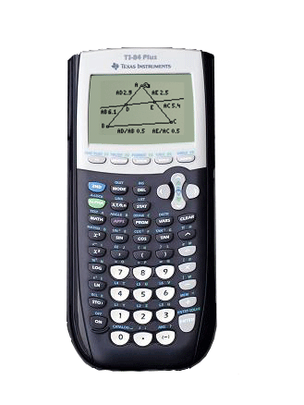

1

2